# Q1.Find the largest of 5 numbers.

#include<stdio.h>

int main()

{

    int a[5],max,i;

    printf("enter 5 numbers\n");

    for(i=0;i<5;i++)

    scanf("%d",&a[i]);

    max=a[0];

    for(i=0;i<5;i++)

    {

        if(a[i]>max)

        max=a[i];

    }

    printf("the largest of 5 numbers is:%d",max);

    return 3;

}

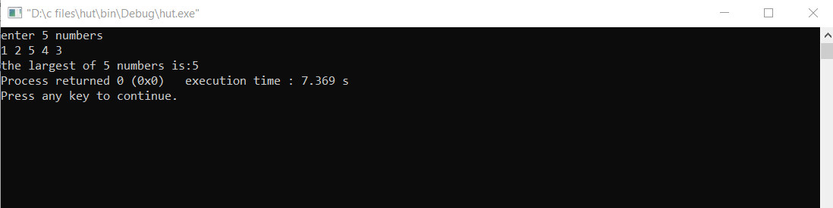

# Q2. Find if a number is even or odd.

#include <stdio.h>

int main()

{

    int a;

    printf("enter a number\n");

    scanf("%d", &a);

    if (a % 2 == 0)

        printf("%d is even.\n",a);

    else

        printf("%d is odd.\n",a);

    return 3;

}

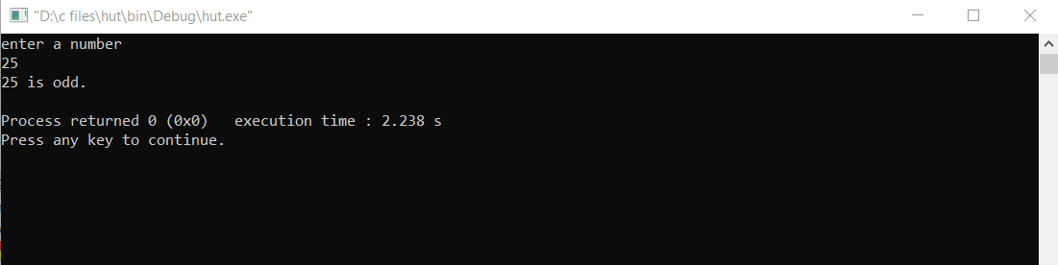

# Q3. Find if a number is positive, negative, or zero.

#include <stdio.h>

int main()

{

    char num;

    printf("enter a number\n");

    scanf("%c", &num);

    switch (num)

    {

    case '-':

        printf("number is negative\n");

        break;

    case '0':

        printf("number is zero\n");

        break;

    default:

        printf("number is positive\n");

    }

    return 3;

}

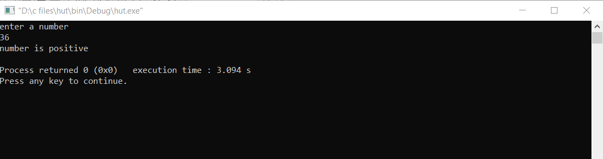

# Q4. Find the type of triangle from its sides – scalene, isosceles, right-angled, isosceles rightangled, or equilateral.

#include <stdio.h>

int main()

{

    float a, b, c;

    printf("enter the sides of the triangle\n");

    scanf("%f %f %f", &a, &b, &c);

    if (a + b > c || b + c > a || c + a > b)

    {

        if (a == b && b == c && c == a)

        {

            if (a * a + b * b == c * c || b * b + c * c == a * a || c * c + a * a == b * b)

                printf("right angled equilateral triangle\n");

            else

                printf("equilateral triangle\n");

        }

        if (((a == b && a != c && b != c) && a * a + b * b == c * c) || ((a != b && a == c && b != c) && b * b + c * c == a * a) || ((a != b && a != c && b == c) && c * c + a * a == b * b))

        {

            printf("right angled isosceles triangle\n");

        }

        else if((a==b) || (b==c) || (c==a))

            printf("isosceles triangle\n");

        if (a != b && a != c && b != c)

        {

            if (a * a + b * b == c * c || b * b + c * c == a * a || c * c + a * a == b * b)

                printf("right angled scalene triangle\n");

            else

                printf("scalene triangle\n");

        }

    }

    else

        printf("invalid triangle\n");

    return 3;

}

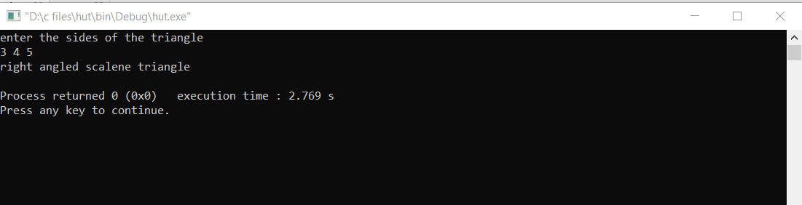

# Q5. Perform basic arithmetic using switch case – take user choice of operation (addition, subtraction, multiplication, division) and print outputs accordingly.

#include <stdio.h>

int main()

{

    float a, b;

    int choice;

    printf("enter two numbers\n");

    scanf("%f %f", &a, &b);

    printf("enter one of the following\n");

    printf("1.addition\n");

    printf("2.subtraction\n");

    printf("3.multiplication\n");

    printf("4.division\n");

    printf("enter your choice\n");

    scanf("%d", &choice);

    switch (choice)

    {

    case 1:

        printf("the sum of %.f and %.f is:%.f\n", a, b, a + b);

        break;

    case 2:

        printf("the difference of %.f and %.f is:%.f\n", a, b, a - b);

        break;

    case 3:

        printf("the product of %.f and %.f is:%.f\n", a, b, a * b);

        break;

    case 4:

        printf("the quotient obtained upon dividing %.f by %.f is:%.2f", a, b, (a / b));

        break;

    default:

        printf("entered valid choice\n");

    }

    return 3;

}

# 

# Q6. Print the number of days of a month based on the month number, using switch case.

#include <stdio.h>

int main()

{

    int mn, y;

    printf("enter month number\n");

    scanf("%d", &mn);

    switch (mn)

    {

    case 2:

        printf("enter year\n");

        scanf("%d", &y);

        if ((y % 4 == 0 && y % 400 == 0) || (y % 100 != 0))

            printf("no. of days:29\n");

        else

            printf("no. of days:28\n");

        break;

    case 1:

    case 3:

    case 5:

    case 7:

    case 8:

    case 10:

    case 12:

        printf("no. of days:31\n");

        break;

    case 4:

    case 6:

    case 9:

    case 11:

        printf("no. of days:30\n");

        break;

    default:

        printf("enter valid month\n");

    }

    return 3;

}

